

**DIAGNOSIS OF ACUTE DISEASES IN VILLAGES AND SMALLER TOWNS USING AI**

Team details

|  |  |  |
| --- | --- | --- |
| Sl. no. | Roll no. | Name |
| 1. | 20211CAI0155 | Benakeshwar G K |
| 2. | 20211CAI0153 | Vishwas Chandra C |
| 3. | 20211CAI0121 | Gautham Ashwani |
| 4. | 20211CAI0099 | Darshan Karthik KJ |
| 5. | 20211CAI0131 | Preethi N |

School of Computer Science ,

Presidency University, Bengaluru

Under the Supervision of

**Dr. MURALI PARAMESWARAN**

**Professor**

**School of Computer Science and Engineering, Presidency University.**

|  |  |
| --- | --- |
| Sl. no. | Content |
| 1 | Introduction |
| 2 | Literature Survey |
| 3 | Objective |
| 4 | Methodology |
| 5 | Architecture Diagram |
| 6 | Project Timeline |
| 7 | References |

# [1] **INTRODUCTION**

* Diagnosis of serious illnesses is often difficult in rural areas due to limited access to healthcare.
* In these cases, timely and accurate health information is essential to ensure early diagnosis and effective treatment. A shortage of doctors in remote villages makes it difficult for residents to receive reliable diagnosis and guidance, resulting in delays in treatment and increased rates of inadequate prevention.
* The project aims to create a chatbot that will provide instant help in diagnosing serious diseases based on user input. The system provides health advice by identifying symptoms and using its medical knowledge base, acting as a virtual doctor in remote areas.
* The aim is to improve access to affordable diagnostic services in rural communities, thus ensuring timely treatment. The solution allows residents to better manage their health and closes the gap between them and the healthcare system.

# [2] **LITERATURE SURVEY**

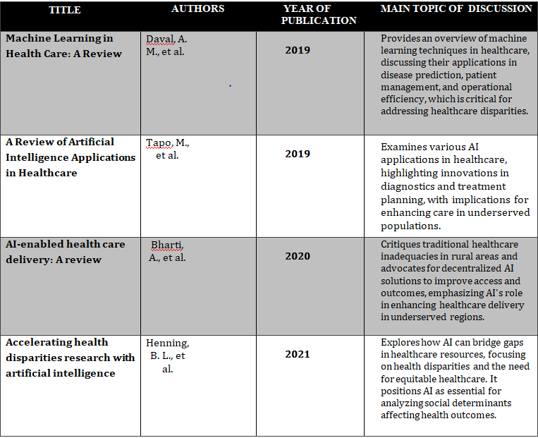

[3] **OBJECTIVE**

* **Early and accurate detection:** Timely diagnosis is essential for effective treatment and reduction of problems in rural areas. AI can help diagnose symptoms in a timely manner, provide early interventions, and reduce the risk of infection, especially in cases where doctors are scarce.
* **Access to Affordable Healthcare:** Providing affordable healthcare guarantees that economically disadvantaged groups are included. AI chatbots are bridging the gap between rural communities and primary healthcare by providing low-cost initial diagnosis and guidance.

[4]  **METHODOLOGY**

**BACK-END**

**Data Processing and Knowledge Base Creation**

We extract relevant medical information from the dataset, converting it into manageable text chunks. These chunks are transformed into vector embeddings using sentence-transformers and stored in a semantic index within a vector database, ensuring efficient retrieval of information.

**FRONT-END**

**User Interaction and Response Generation**

Users submit queries that are converted into query embeddings and matched against our knowledge base to retrieve ranked results. The responses are then generated using Llama2, allowing for accurate and contextually relevant answers. This approach will benefit users in villages by providing timely access to medical information and facilitating self-management of minor conditions, ultimately enhancing healthcare outcomes in underserved areas.

**TOOLS AND LIBRARIES**

**LangChain :** Handles Llama2 model and embedding queries (**langchain==0.0.225**).

recursiveCharacterTextSplitter: Divides text into chunks with overlap for better token management.

**SentenceTransformers (HuggingFace) :** Converts text chunks into embeddings (**sentence-transformers==2.2.2**).

**Pinecone :** Stores and queries vector embeddings in a semantic index (pinecone-client).

**Flask :** Manages API endpoints and the web interface (flask).

**Llama2** : Filters ranked results based on user queries embedded and matched in the vector database.

**PyPDF :** Used for handling PDF data (pypdf).

Frontend : **Flask**

[5] **ARCHITECTURE DIAGRAM**

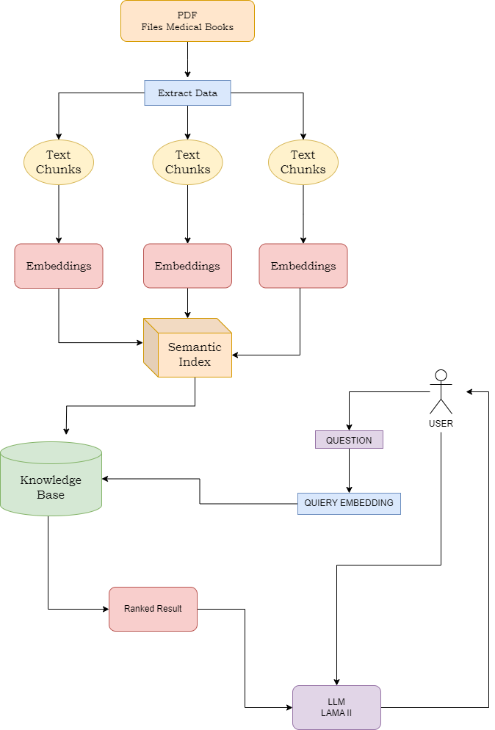

# [6] **PROJECT TIMELINE**

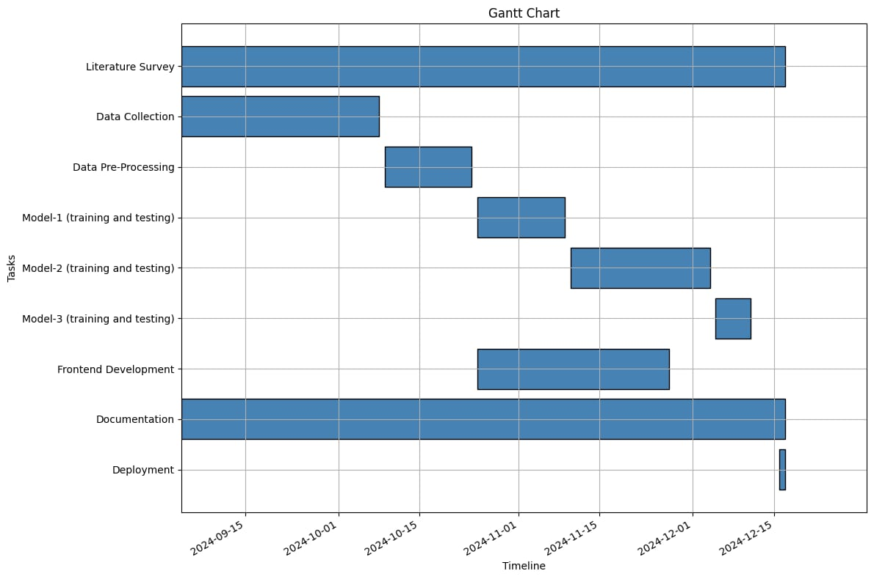

1. **Literature Survey**

(2024-09-15 to 2024-12-15):  
The literature survey is conducted continuously throughout the project to ensure the research stays aligned with existing studies and new findings in AI and healthcare applications.

1. **Data Collection**

(2024-09-15 to 2024-10-15):  
Data collection phase involves gathering relevant medical information, including symptoms, diseases, and treatment data to train the chatbot system.

1. **Data Pre-Processing**

(2024-10-01 to 2024-11-15):  
This stage focuses on cleaning, organizing, and preparing the collected data for training models. Pre-processing includes chunking large datasets into manageable portions and ensuring data consistency.

1. **Model-1 (Training and Testing)**

(2024-10-15 to 2024-11-15):  
The first model is developed and tested. This involves using initial AI techniques to train the chatbot on the collected medical data and evaluating its performance.

1. **Model-2 (Training and Testing)**

(2024-11-01 to 2024-12-01):  
A second iteration of the AI model is trained with refined methods and additional data to improve accuracy and performance in symptom diagnosis.

1. **Model-3 (Training and Testing)**

(2024-12-01 to 2024-12-15):  
The final model undergoes training and testing with comprehensive datasets to fine-tune its diagnostic capabilities before deployment.

1. **Frontend Development**

(2024-11-01 to 2024-12-15):  
This phase involves building the user interface for the chatbot system, ensuring it is user-friendly, accessible, and compatible with the target audience's needs.

1. **Documentation**

(2024-09-15 to 2024-12-15):  
Detailed documentation of the project progress, methodologies, and results is maintained throughout the timeline, ensuring clarity and transparency in the development process.

1. **Deployment**

(2024-12-15):  
The final chatbot model is deployed, making the system available for use in diagnosing medical conditions based on user input in rural areas.

# [7] **REFERENCES**

1. **Kumar Y, Koul A, Singla R, Ijaz MF. "Artificial intelligence in disease diagnosis: a systematic literature review, synthesizing framework and future research agenda." *J Ambient Intell Humaniz Comput*. 2023;14(7):8459-8486. doi:10.1007/s12652-021-03612-z.**
2. **Guo, Jonathan &Li, Bin. (2018). "The Application of Medical Artificial Intelligence Technology in Rural Areas of Developing Countries." *Health Equity*. 2:174-181. doi:10.1089/heq.2018.0037.**
3. **Pathak, Chandramaprasad and Ansari, Namrata. "Chatbot based Disease Prediction and Treatment Recommendation using AI." (May 7, 2021).**

**Available at SSRN:** [**https://ssrn.com/abstract=3869072**](https://ssrn.com/abstract=3869072)

1. **Fan X, Chao D, Zhang Z, Wang D, Li X, Tian F. "Utilization of Self-Diagnosis Health Chatbots in Real-World Settings: Case Study." *J Med Internet Res*. 2021 Jan 6;23(1)**
2. **Diagnosis Of Acute Diseases In Villages And SmallerTowns Using AIMohammed Naseeruddin Taufiq, Bandaru Bhavagna Shreya, Sahil Anil Thole Chitra S, A.Mohammed A**
3. **Using AI, Diagnosis of Acute Diseases in Villages and Smaller TownsMadhu H T1, Sachin S2, Manjunath Kavishetti3 , Puneeth4 , Karthik Mahesh Gadyal5**
4. **.Chakraborty, Sanjay, Paul, Hrithik, Ghatak, Sayani, Pandey, Saroj, Kumar, Ankit, Singh, Kamred, & Shah, Mohd Asif. (2023). "An AI-Based Medical Chatbot Model for Infectious Disease Prediction." *IEEE Access*. PP. 1-1. doi:10.1109/ACCESS.2022.3227208.**